freETarget
Application Note: Advanced Operation

SUMMARY
The original intention of the FreeETarget product was for operation in a simple ten-meter air gun range. This requirement was easily satisfied using a single fifteen-meter USB cable which provided power and data to the target. While this worked well for a single target, it becomes cumbersome for multiple targets or targets placed longer than ten meters away. Over time, various hardware and software changes have been made to accommodate these advanced use cases.
This application note describes using FreeETarget in advanced operations:
REQUIRED
- ESP32 Firmware Version 6.3.0 or higher
- freETarget PC software

ALTERNATE INSTALLATION METHODS
The default operation of the target is a single target on a ten-meter range. This is satisfied using a fifteen-meter USB cable, or a battery and WiFi. When expanded to a large range with three or more lanes or longer distances, the WiFi can become problematic. To help in these cases, the target can be configured with alternative cabling or networks.
Connection | Advantage | Disadvantage | Note
USB Cable | Simple  Allows for target software updates | Requires special cable
RS485 | Inexpensive Wiring | Requires that the target be powered by 12Volt Supply | Cannot be used at the same time as Ethernet
Ethernet | Reliable communications  Multiple Targets on one network | Requires cabling and a router to implement | Cannot be used at the same time as RS485
WiFi | Multiple targets on one network | Requires expertise in network management

Any one target can use these communications methods either singly or together.

Simple Target Installation
Regardless of the final configuration of the target, all FreeETarget installations share the same common features
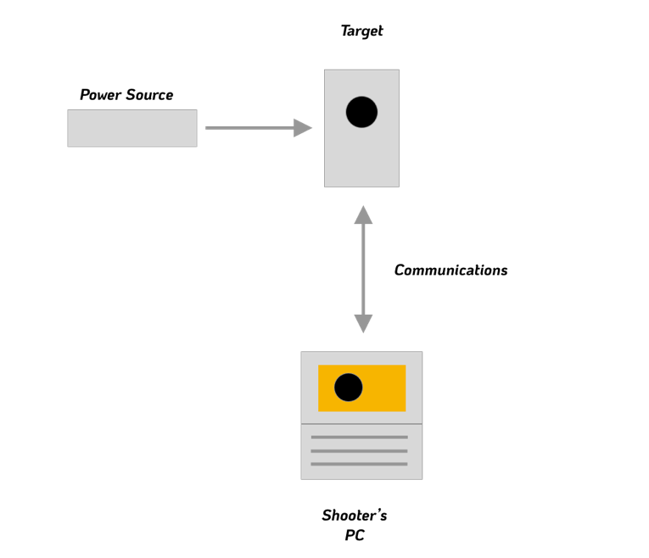
Figure 1: Simple Target Installation
When using witness paper or the LED illumination the target needs a power supply. Choices include
- USB power bank
- USB cable connected to a PC
- 12VDC-2A wall power supply
This application note describes the steps needed to install multiple targets side-by-side in a single shooting range. The steps are:
- Give the target a name
- Put the target onto the home WiFi
- Assign an IP address
- Calibrating the target

Shooting Ranges
A shooting range typically has multiple target stands, and each target stand can be observed by one or more people. Figure 2 illustrates a typical shooting range setup.
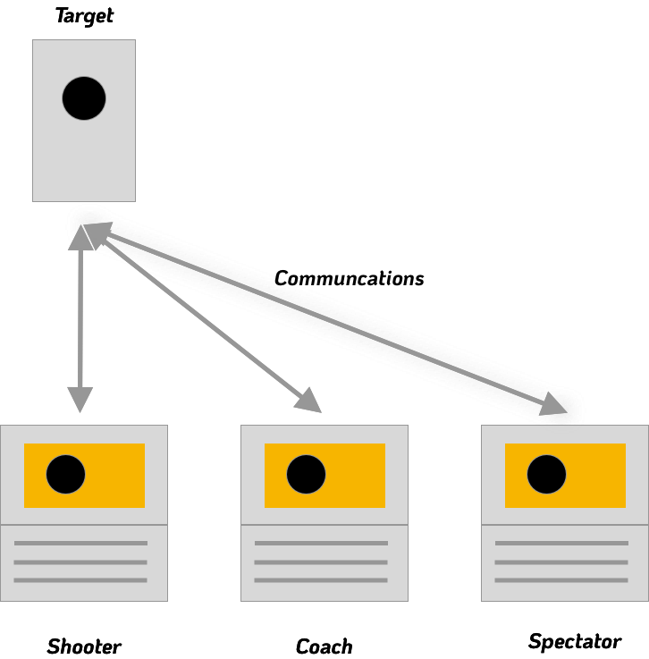
Figure 2: Sample Shooting Range

In the shooting range, the target is used by the shooter to see their shots. At the same time, the coach may be looking at the shots on another screen, while spectators may be watching at another location. This setup will be repeated for each active shooting lane.
Each shooting lane operates as-if it was a single user at someone’s home. The differences are:
- Multiple communications channels
- Increased wiring costs

To accommodate these changes, FreeETarget offers multiple communications methods that can be used singly or together as needed. These include
- Single USB connection between target and PC
- Duplicate RD485 connection between target and PC
- WiFi connection between between target and up to four PCs

Single USB Connection
A single USB connection between the PC and the target is the simplest means of using the target. The USB provides communication and power to the target.
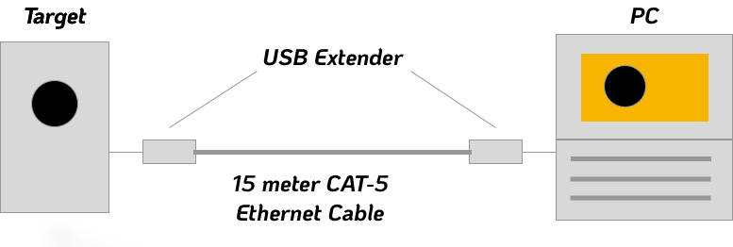
Figure 3: USB Extender
The Amazon.com order numbers are provided in Table 3.
Table 3: Amazon Part Numbers of USB Installation
Item | Description | AMAZON.COM ASIN
1 | USB Extender | B06WGVX3NQ
2 | CAT 5 Cable | B0BJNZ71K3
The single USB connection is recommended for each target lane since it provides an easy interface to each target and in addition to showing the shot data can be used for configuration and reprogramming.

RS485 Connection
FreeETarget supports a low cost RS485 connection between the PC and the target. While similar to the USB connection, RS485 has some differences
PRO
Low cost cable
Range up to 190 meters
CON
Does not supply power to the target.
Starting with board version 6.2 and higher, the RS-485 circuit is built onto the target circuit. For versions 5.0 to 6.1 you will need to add an additional adapter

Version 6.2 and Higher

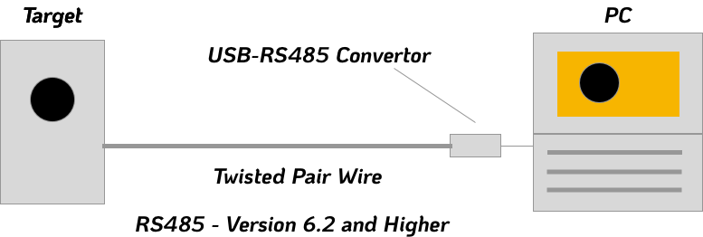

Starting with Version 6.2, the RS485 interface is installed directly onto the board. Simply attach the twisted pair wires to the A and B screw terminals and set the configuration into the software and reboot the board.
{“AUX_MODE”:8}
Table 4: Amazon Part Numbers of USB Installation
Item | Description | AMAZON.COM ASIN
1 | USB-RS485 Convertor | B07QN6JVG1
2 | Twisted Pair Wire | B0CQMSWVYY

Version 5.0 to 6.1

Prior to 6.2, FreeETarget boards do not have RS485 natively installed, but can be achieved by adding an ES485 convertor to the board and attaching it by a cable harness

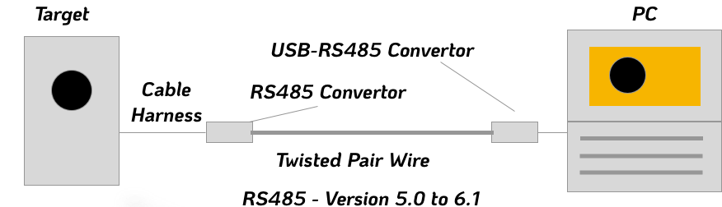
Figure 3: USB Extender
The Amazon.com order numbers are provided in Table 3.
Table 3: Amazon Part Numbers of USB Installation

Item | Description | AMAZON.COM ASIN
1 | USB Extender | B06WGVX3NQ
2 | CAT 5 Cable | B0BJNZ71K3

The cable harness between the ESP32 board and the RS485 adapter is given in Figure
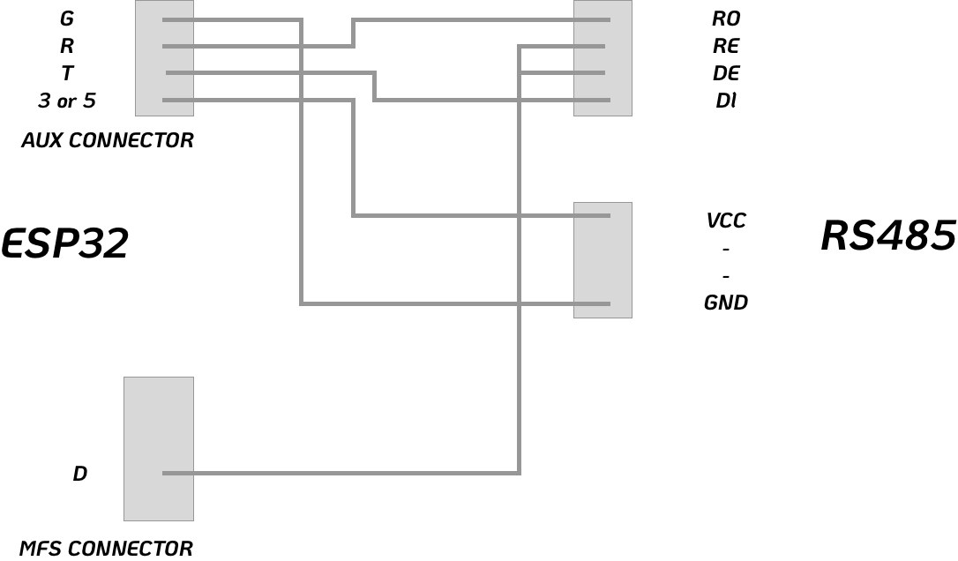
The RS485 driver is enabled by
{“AUX_MODE”:8, “MFS_HOLD_D”:30}

Wired LAN (Ethernet) Connection
A wired Ethernet connection is a reliable way of connecting all of the targets in a range. This method provides the advantage of multiple connections without collisions.
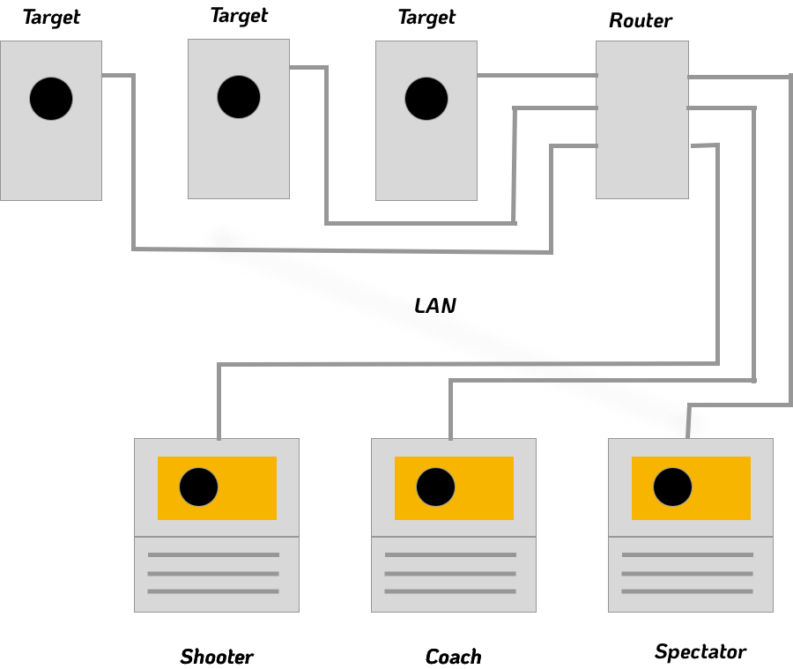

The FreeETarget connects to the LAN using an Ethernet adapter as shown in Figure
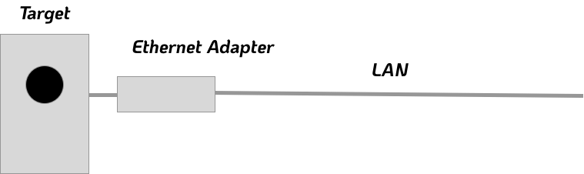

Each target requires the items shown in Table

Item | Description | Part Number
1 | Ethernet Serial Convertor | USR-TCT232-T2
2 | CAT 5 Cable | Amazon B0BJNZ71K3

The connection between the ESP32 board and the convertor depends on the version of ESP board that is used.

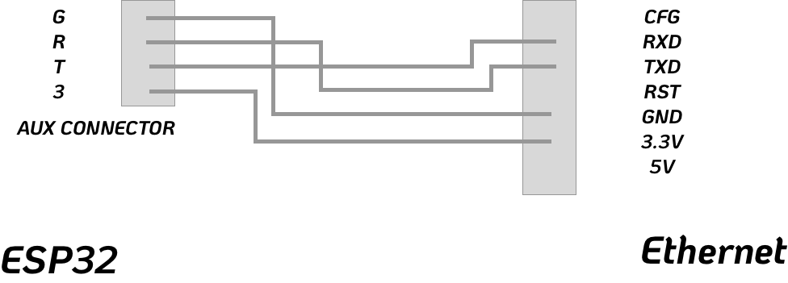
Version 6.2 and higher

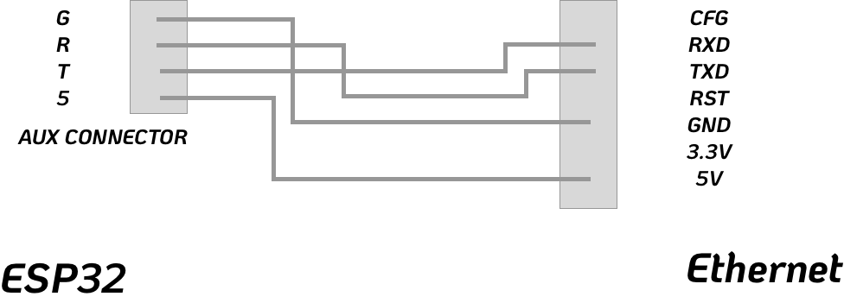
Version 5.0 to 6.1
Note that Version 5.0 to 6.1 supply 5 Volts, while 6.2 and higher supply 3.3
Once attached, the FreeETarget board is configured with
{“AUX_MODE”:1}
Programming the USR-TCP232-T2
The USR-TCP-232-T2 needs to be set up with the following
- The IP address of the convertor to be used on the host network
- Set into server mode
- Setup with the correct communication port
- Setup the communications rate
The first time through, the modules must be programmed in a specific sequence.
- Power the module from a FreeETarget board
- Directly connect the convertor to the PC using a direct wired connection
- Open the LAN setup from your PC setup tab
- Set your PC for a static IP with
  - IP address 192.168.0.1
  - Subnet Mask 255.255.255.0
  - DNS lookup 192.168.0.7
- Open a web browser and connect to 192.168.0.7
- Password admin
- ID: admin
- Set the LAN converter to
  - an address on your desired network, something like 192.168.1.100
  - Server mode
  - Port 1090
- Save and exit the configuration
IMPORTANT
- The converter is very unforgiving if you forget the IP address you set it to.
- Mark the IP address onto the board
- DO NOT change the username or password. If you forget the password, there is no way to recover it
The manuals for the convertor can be found at
https://www.pusr.com/download/M0/USR-TCP232-T2-User-Manual-V1.1.pdf&ved=2ahUKEwj23JqOicuTAxXplWoFHVe8G9MQFnoECBsQAQ&usg=AOvVaw3Va5z5EbAdktlITQ1JQrvF
Configuration Software
https://www.pusr.com/support/faq/usr-tcp232-t2-basic-function-test.html

WiFi Operation
Multiple FreeETargets can be setup on a host network to provide interoperability across multiple targets and multiple PCs. This is illustrated in Figure.

When setup this way, any pc can be attached to any target so that a coach can jump between shooters to watch their progress.
In order to do this, the network has to be setup for the application.

SETUP THE RANGE
The range is setup as shown in Figure 1. The targets are installed as usual and located nearby is the WiFi router. The router should be no more than forty (30) meters from the targets. The Shooter’s PC should be located such that they get a strong signal from the router.
WiFi routers come with the ability to directly connect the PC to the router using an Ethernet cable. Leave this in place since it allows remote diagnostics via TeamViewer and the service PC.
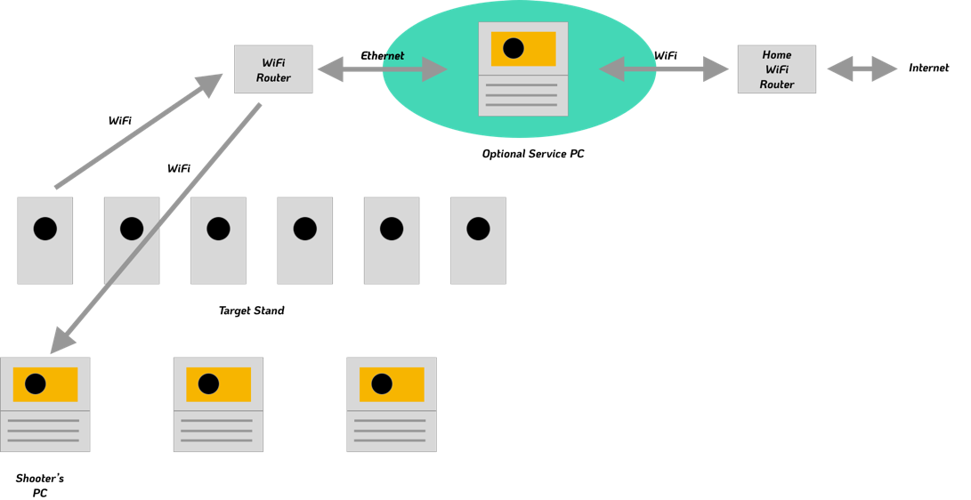
Figure 1: Preferred Range Setup
Router Setup
The router should be setup for the convenience of the shooter and their PC. The following settings are suggested.
Setting | Value | Description
SSID | TargetRange | Easy to recognize
Password | None (open wifi) | No secure data, easy to access for members
IP Address | 192.168.109.x | Unique IP address that will not likely conflict with other networks

Target Setup
The target should be setup with the following values
Setting | Description
{“WIFI_SSID”:”TargetRange”} | Set to the same SSID as the router
{“WIFI_PWD”:””} | No password used.  Use {“WIFI_PWD”:”mypassword”} if a password is used in the router.
{“NAME_ID”:x} | Select a unique (different) name ID for each target  See Appendix
 | Optional
{“WIFI_IP”:”IP address”} | Set in a static IP, ex {“WIFI_IP”:”192.168.109.111”}

ACCESSING THE TARGET
Once the targets and router have been setup, the target can be accessed much like any other network device you have.
Using the PC Client
In the client configuration, set in the IP address in the TCP configuration as shown in Figure 3
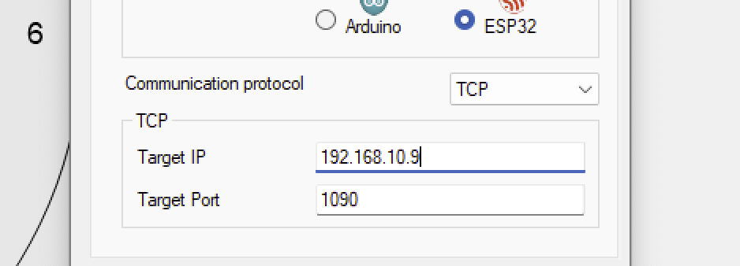
Figure 3: Setting the Target IP Address
When the target connects, it will connect to the IP address and begin the session.
The target will accept up to four simultaneous connections:
- Shooter
- Coach
- Parent
- Observer

Using a Web Browser
The target can be accessed as a web page using a web browser such as Safari or Chrome.
By IP address for example: 192.168.109.23
By target name, for example FET-TARGET.local

SECURITY
The design of FreeETarget assumed a fair amout of trust between the shooters and the shooting range. If this is not the case, then the following steps can be added
- Assign a WiFi password to the target range
- Lock out the target settings by assigning a lock code {“LOCK”:number}. This will prevent anyone from changing the settings unless an unlock code is provided {“UNLOCK”:number}

CAUTIONS
- When using the browser, only one connection will be accepted.
- The target has a WiFi range of fifty-meters in a clear line of sight with no obstructions
- The range manager should assign a WiFi password if they are concerned about security

ASSIGN A TARGET NAME
Each target can be assigned a name so that it is easily identified later.
In the Generic Command field, enter the command
{“NAME_ID”:x} where X is the name ID. The list of
0 – FET-TARGET. (Default)
1 – FET-1  2 – FET-2  3 – FET-3  4 – FET-4  5 – FET-5  6 – FET-6  7 – FET-7  8 – FET-8  9 – FET-9  10 – FET-10 | 11 – DOC  12 – DOPEY  13 – HAPPEY  14 – GRUPMY  15- BASHFUL  16 – SNEEZY  17 - SLEEPY | 18 – RUDOLF  19 – DONNER  20 – BLITZEN  21 – DASHER  22 – PRANCER  23 – VIXEN  24 – COMET  25 – CUPID  26 - DUNDER | 27 – ODIN  28 – WODEN  29 – THOR  30 - BALDAR
Using a NAME_ID of 99 allows the operator to assign a new name to the target.
{“NAME_ID”:99. “NAME_TEXT”:”MyNewTarget”}

CALIBRATING THE TARGET
When operating alone, the calibration constants are stored in the PC. However this means that if the shooters bring their own PCs with them, then the calibration will need to be done every time a new PC is connected to the target. Starting in Version 6.0, the calibration constants can be stored in the target so that the PC client can be switched between targets.
- Connect to the target as you would normally
- Use a conventional target with scoring rings
- Shoot five shots into the target, fairly well spaced
- Open the calibration icon (Upper right, small cross-hairs)
- The Calibration dialog box will appear
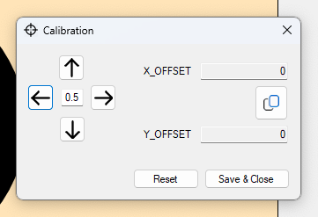
- Reset the calibration.
- Using the four arrows, adjust the shots on the screen to align with the shots on the paper
- Press the copy button (two overlapping squares)
- X out of the calibration screen,. Do not press Save & Close
- Return to the Diagnostics Terminl
- Paste the calibration settings into the Generic Command Box
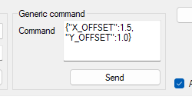
- Press SEND
This will save the calibration into the target for the next shooter.

APPENDIX 1
Target Names
NAME ID | Target Name
0 | TARGET (Default)
 | Numbers
1 | 1
2 | 2
3 | 3
4 | 4
5 | 5
6 | 6
7 | 7
8 | 8
9 | 9
10 | 10
 | Seven Dwarves
11 | DOC
12 | DOPEY
13 | HAPPY
14 | GRUMPY
15 | BASHFUL
16 | SNEEZY
17 | SLEEPY
 | Reindeer
18 | RUDOLF
19 | DONNER
20 | BLITZEN
21 | DASHER
22 | PRANCER
23 | VIXEN
24 | COMET
25 | CUPID
26 | DUNDER
 | Norse Gods
27 | ODIN
28 | WODEN
29 | THOR
30 | BALDAR
 | Custom
31 | TEST
99 | {“NAME_TEXT”:”myName”}. -> FET-myName
100 | {“NAME_TEXT”:”myName”}. -> myName
101 | Serial number -> FET-SerialNumber

